Lab Task 1:

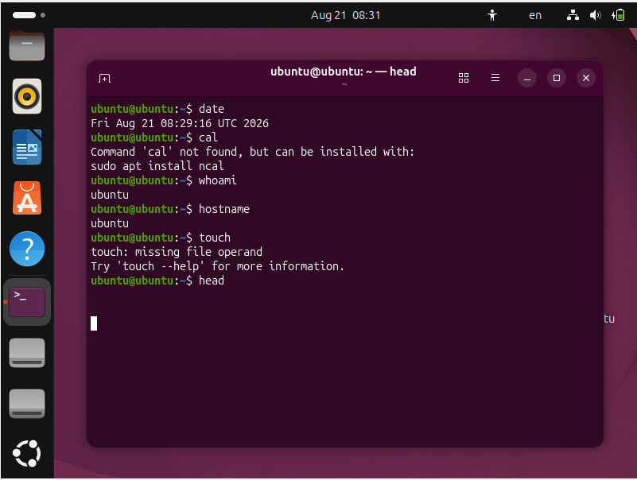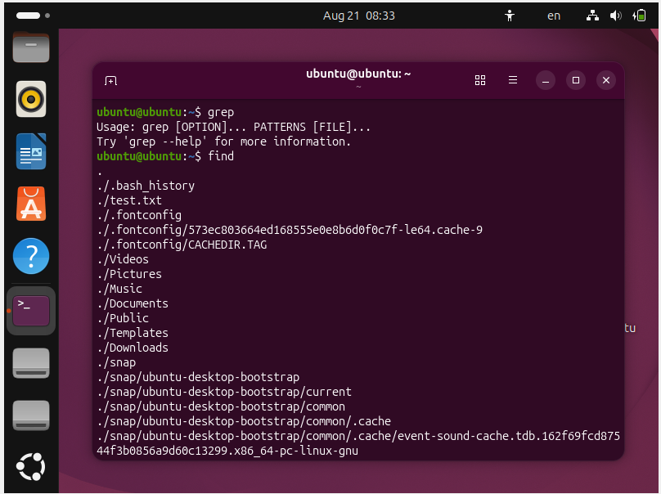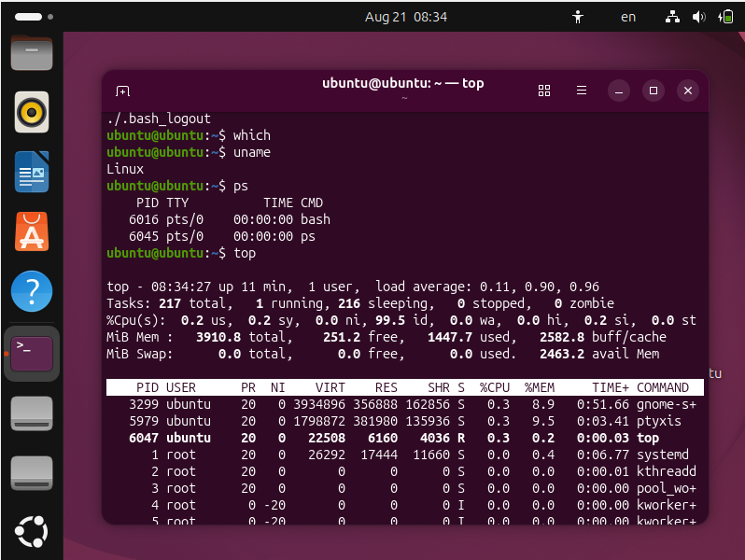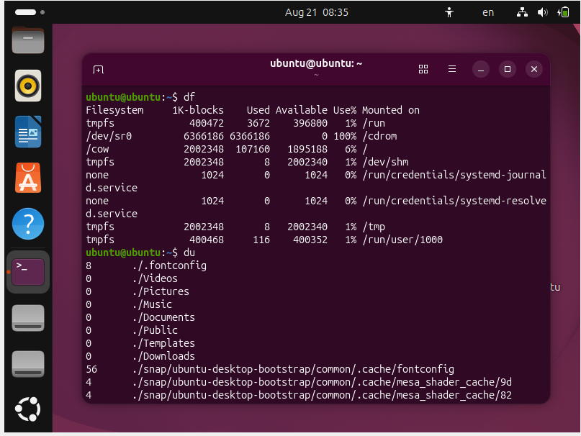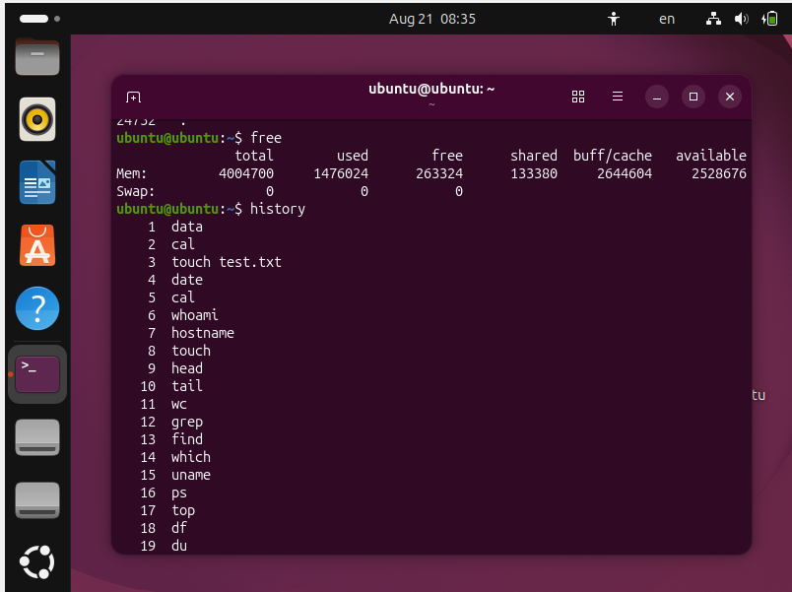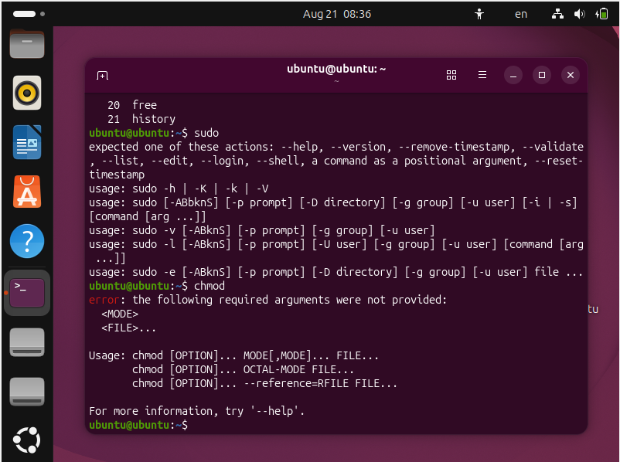

Lab Task 2: 10 Linux Distributions
Linux has many distributions (distros). Each distribution is based on the Linux kernel but may have different software, package managers, desktop environments, and purposes.
No. | Linux Distribution | Brief Description
1 | Ubuntu | A popular, user-friendly Linux distribution based on Debian. It is widely used for desktops, servers, programming, and education.
2 | Debian | A stable and reliable Linux distribution known for its large software repository and strong community support.
3 | Fedora | A modern Linux distribution sponsored by Red Hat. It provides newer technologies and is popular among developers.
4 | Linux Mint | A beginner-friendly distribution based mainly on Ubuntu. It provides a familiar desktop experience for Windows users.
5 | Arch Linux | A lightweight and highly customizable distribution designed for users who want complete control over their system.
6 | Kali Linux | A security-focused Linux distribution commonly used for penetration testing, digital forensics, and cybersecurity.
7 | openSUSE | A Linux distribution known for system administration tools and is available in different editions for desktop and server use.
8 | CentOS Stream | A Linux distribution closely related to Red Hat Enterprise Linux and used mainly in server and enterprise environments.
9 | Rocky Linux | An enterprise-focused Linux distribution designed to be compatible with Red Hat Enterprise Linux.
10 | AlmaLinux | A free, open-source enterprise Linux distribution designed as a stable alternative for server environments.

Conclusion
Linux distributions are designed for different purposes. Ubuntu and Linux Mint are suitable for beginners, Kali Linux is useful for cybersecurity, while distributions such as Rocky Linux and AlmaLinux are commonly used for enterprise and server environments.

Lab Task 3: Comparison of Three Common Operating Systems
The three commonly used operating systems are Microsoft Windows, macOS, and Linux. They differ in their design, licensing, security, customization, and hardware support.
Feature | Windows | macOS | Linux
Developer | Microsoft | Apple | Open-source community and organizations
Kernel | Windows NT Kernel | XNU | Linux Kernel
Source Code | Mostly closed-source | Mostly closed-source | Open-source
Hardware Support | Works with many different manufacturers | Mainly Apple hardware | Works with many types of hardware
User Interface | Very user-friendly | Simple and polished | Depends on distribution and desktop environment
Customization | Moderate | Limited | Very high
Security | Good, but commonly targeted by malware | Generally strong | Generally strong
Software Availability | Very large selection of commercial software | Large selection, especially creative software | Large selection of open-source software
Gaming | Excellent gaming support | Moderate | Improving, but generally less than Windows
Cost | Usually requires a license | Included with Apple hardware | Mostly free
Package Management | Microsoft Store and installers | App Store and installers | Package managers such as APT, DNF, and Pacman
Best For | General users, business, and gaming | Apple users, creative work, and development | Programming, servers, education, and customization

1. Windows
Windows is developed by Microsoft and is one of the most widely used desktop operating systems. It supports a large variety of hardware and software. It is particularly popular for gaming, business applications, and general-purpose computing.

2. macOS
macOS is developed by Apple and is designed primarily for Mac computers. It provides a polished and consistent user interface and is popular among developers, designers, video editors, and other creative professionals.

3. Linux
Linux is an open-source operating system based on the Linux kernel. It is available in many distributions such as Ubuntu, Debian, Fedora, and Linux Mint. Linux provides high customization and is widely used in servers, programming, cybersecurity, cloud computing, and education.

Conclusion
Each operating system has its own advantages. Windows is suitable for general-purpose computing and gaming, macOS is well suited for Apple hardware and creative work, while Linux is highly customizable and popular for programming, servers, and cybersecurity. The best operating system depends on the user's requirements.

